Investigating health care professional and patient views and experiences of FeNO-guided asthma management:

Interviews with patients with asthma

Information for participants aged 12-15

Why are we doing this study?
- We are doing this study to find out how we can help doctors and nurses use a breath test called FeNO when they do asthma check-ups in GP surgeries.
- Asthma is a common condition that affects the airways of the lungs.
- In people with asthma, swelling (also known as inflammation) can occur in the linings of the airways and make them narrower than usual.
- This can cause symptoms such as wheezing, coughing, chest tightness and shortness of breath.
- If these symptoms flare up badly, people may get asthma attacks, which might need treatment with medicines to reduce inflammation (such as steroids) or admission to hospital.
- Although most doctors and nurses ask people with asthma about their symptoms during check-ups, how someone feels does not always match how much inflammation is in their airways.
- Measuring someone’s FeNO will give doctors and nurses a better idea of how much inflammation is in their airways. This will help them make sure they get the right treatment to prevent them from getting asthma attacks.
- We want to see what people with asthma and the health care professionals who treat you think about using FeNO

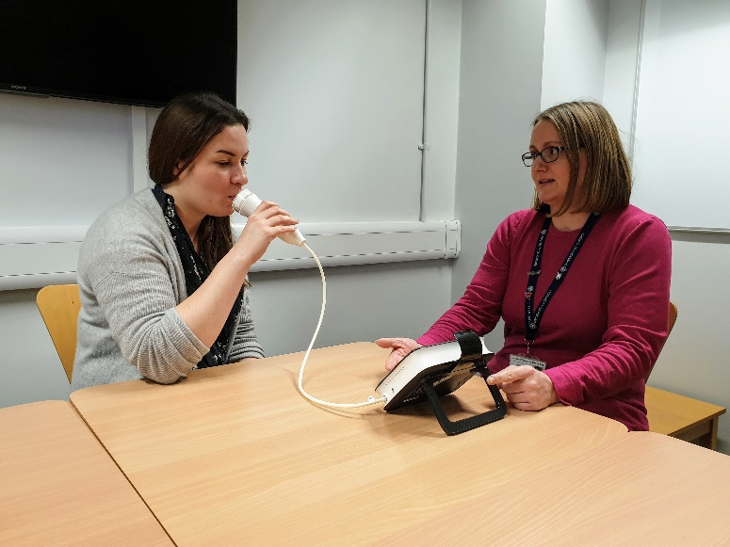

What is FeNO?
- FeNO stands for Fractional exhaled Nitric Oxide and it is measured using a simple breath test.
- People with a high FeNO have more inflammation in their airways and are more likely to have an asthma attack. This might be because they are not on enough medicine to reduce inflammation, or because they are not taking their medicine correctly.
- People with a low FeNO have less inflammation in their airways and are less likely to have an asthma attack. This might be because they are on the right medicine, but could mean they are taking more medicine than they need.

What will happen if I decide to take part?
- A researcher from the University of Oxford will talk to you and a parent or carer about the study and ask if you want to take part and if you have any questions about taking part.
- If you are happy to take part, the researcher will ask your parent or carer to sign a consent form. If you are happy to take part in the study you can sign an assent form to say that you are happy to take part. The interview will be done over the telephone or online (e.g. using Skype or Microsoft Teams), whichever you prefer. The consent and assent forms will be read out to you. You will receive copies of consent and assent forms by email.
- During the interview, a researcher will ask you about your asthma and about your experience of using FeNo in the past or what your thoughts are about using it in the future when you have an asthma check-up. A parent or carer will join the interview.

What if there is a problem?
- If you are not happy with something about the study, please tell us or ask your parent or carer to tell us.

Do I have to take part?
- No, you don’t have to take part, but you may want to talk to your parent or carer before making up your mind.

What will happen if I want to stop doing the study?
- If you want to stop doing the study at any time, please tell the researcher or get your parent or carer to tell them. No one will be cross with you if you decide you want to stop.

What will happen to the results of the study?
- We will put the results on our website www.definestudy.com for you to read.

Thank you for reading this. Please ask us if you have any questions.
Our contact details: Nuffield Department of Primary Care Health Sciences, Radcliffe Primary Care Building, Radcliffe Observatory Quarter, Woodstock Road, Oxford, OX2 6GG
Study contact: Dr Marta Santillo (marta.santillo@phc.ox.ac.uk; telephone: 01865 289350)

