PARTICIPANT INFORMATION LEAFLET
Development and Evaluation of an online FeNO-guided asthma management INtervEntion in primary care: feasibility study (DEFINE-Feasibility)

We'd like to invite you to take part in our research study. Before you decide, it is important that you understand why the research is being done and what it would involve for you. Please take time to read this information, and discuss it with others if you wish. If there is anything that is not clear, or if you would like more information, please ask us.

What is the purpose of the study?
Asthma is a common condition which affects the airways of the lungs. In people with asthma, swelling (also known as inflammation) can occur in the linings of the airways and make them narrower than usual. This can cause symptoms such as wheezing, coughing, chest tightness and shortness of breath. If these symptoms flare up badly, people may get asthma attacks, which might need treatment with medicines to reduce inflammation (such as steroids) or admission to hospital.
At the moment, most health care professionals rely on patients’ symptoms to help them decide how to treat their asthma. However, how someone feels does not always match how much inflammation is in their airways or how likely they are to have an asthma attack. We are therefore developing an online package to support health care professionals in general practices with using a simple breath test called fractional exhaled nitric oxide (FeNO), which measures inflammation in the airways.
At the moment, FeNO is mainly measured in patients with severe asthma who attend hospital clinics. However, very few GP surgeries routinely use FeNO to help them monitor treatment in patients with milder forms of asthma. We would therefore like to find out why this is and learn more about feasibility and practicalities of using FeNO in general practice.
To achieve these aims, we are training health care professionals in GP surgeries in how to measure and use FeNO to help them make decisions about managing their patients’ asthma. We will ask general practices to implement FeNO in their asthma review consultations. Patients who agree to take part will have their FeNO measured during their asthma review. We would like to compare the decisions that were made during an asthma review in which FeNO was measured to recommended care. Also, we will ask patients and health care professionals about their views on using FeNO.

Why have I been invited?

Your general practice surgery is taking part in this study. You have been invited because your general practice team have identified you as someone who has asthma, who is due to have an asthma review.

Do I have to take part?
No, taking part is entirely voluntary and you can withdraw at any time if you later change your mind, without giving a reason. Withdrawal or not taking part will not affect your current or future clinical care in any way, as the research team is separate from your health care team.

What will happen to me if I decide to take part?
A researcher from the University of Oxford will talk to you about the study and ask if you have any questions about taking part. If you would like to take part, the researcher will ask you to complete a consent form.
During your asthma review appointment, your health care professional will measure your FeNO. This will involve you breathing in through a disposable mouthpiece, connected to a machine, then breathing out gently for about 10 seconds. A display screen on the machine will help you ensure that you are breathing out at the right speed.

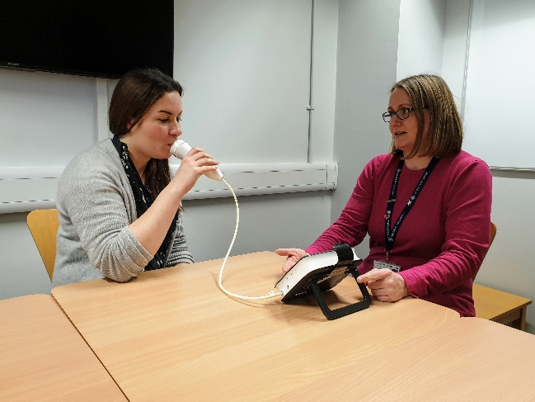

The FeNO mouthpiece is changed between each patient, and the machine is cleaned thoroughly.

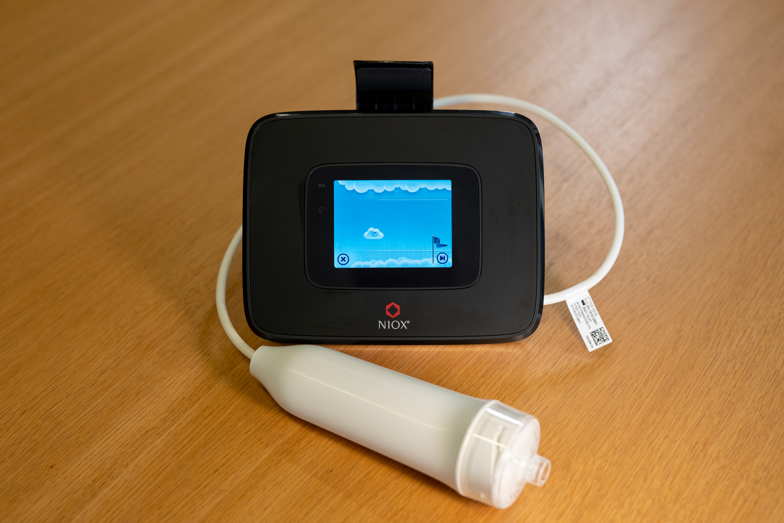
The FeNO machine – you will be asked to hold the white breathing handle and blow into the clear mouthpiece on the end.

Your healthcare professional will follow the Covid-safe procedures of your GP Practice.
After your asthma appointment, the research team would like to look at your medical records to see what decisions were made about your care. We will ask look at your FeNO result.
Additionally, we would like to ask you to complete some questionnaires to ask you about your asthma, your medicines, and your views of the asthma review appointment.
The research team would also like to invite some participants to take part in an interview about their asthma and experience of having their FeNO measured. The interview can be done remotely, for example by telephone, Microsoft Teams or Skype and would last no longer than one hour. We can provide participants invited to interviews with a separate information leaflet with further details.

What should I consider?
The main things to consider are whether you are comfortable with having your FeNO measured and the possibility that your health care professional may wish to consider changing the way your asthma is managed as a result of knowing the FeNO result.

Are there any possible disadvantages or risks from taking part?
If you have not done a FeNO test before, you might feel a bit anxious about what it involves. You can ask your GP Practice if you have any questions. FeNO testing is already done in hospital clinics and is safe, painless, and easy to do.

If you normally have your asthma review done over the telephone, you will have to go to your GP Practice to have your FeNO test done first. This may be less convenient than just having a telephone review. However, doing the test may give your healthcare professional more information about your asthma so they can give you better advice when you do have your telephone review.

You may have concerns about Covid-19 infection as a result of having to go to your GP Practice for your FeNO test. However, your GP Practice will put all necessary measures in place to keep you safe from Covid-19. This will include making sure the FeNO testing equipment is properly cleaned, and attaching a brand new mouthpiece to the machine before you do your test.

You may have concerns about researchers seeing your medical records. We would like to assure you that all data will be kept secure and confidential.

What are the possible benefits of taking part?
The main benefit of taking part in the research is an opportunity for you to contribute to a programme of research that focuses on improving how health care professionals in GP surgeries manage patients with asthma.

Your health care professional may also be able to make better informed decisions about how to manage your asthma as a result of knowing your FeNO result. For example, if your FeNO indicates a high level of inflammation in your airways, they may increase the dose of your existing medication or start you on different medication to reduce this inflammation and lower your risk of having an asthma attack. On the other hand, if your FeNO indicates a low level of inflammation and your asthma is well controlled, they may consider reducing the amount of medication you need to take.

Will my taking part in the study be kept confidential?
Yes. All data from the study which we decide to share with anyone outside the research group or your health care team will be de-identified unless you give us permission not to do this. They will be kept on a secure part of the server at the University of Oxford and only accessible by the research team for up to six years after the end of the study, after which point all audio recordings will be destroyed. In those stored data, you will be referred to only by a code name (‘pseudonym’). We will keep a separate paper record in a locked cabinet of participants’ real names and corresponding code names.
Audio recordings may be processed by a transcriber with a contractual agreement with the University. Transcribers are subject to the same requirements of confidentiality as researchers. They will have no other identifying information about you, and will not retain the audio recordings.
Responsible members of the University of Oxford and the relevant NHS Trust(s) may be given access to data for monitoring and/or audit of the study to ensure that the research is complying with applicable regulations.
In the highly unlikely event that we notice anything about your care which we feel poses a serious risk to your health or safety, we would have a duty to report this to the appropriate manager(s) at your GP surgery and your health care professional’s regulatory body. We would discuss this with you before doing so.

Will I be reimbursed for taking part?
We will not offer reimbursement for having your FeNO measured during your routine asthma review consultation. However, we can offer you a small token of £20 if you are willing to be interviewed by a researcher after your consultation.

What will happen to my data?
Data protection regulation requires that we state the legal basis for processing information about you. In the case of research, this is ‘a task in the public interest.’ The University of Oxford is the data controller and is responsible for looking after your information and using it properly. Your GP surgery and study team will use your name, NHS number, home address, email address and/or phone number to contact you about the research study and to oversee the quality of the study.
We will be using information from interviews and observations and will use the minimum personally-identifiable information possible. We will store research data (de-identified unless we have explicit consent to retain identifiers) and any research documents with personal information (such as consent forms) securely at the University of Oxford for up to six years after the end of the study. This will ensure that we have time to analyse it all, write papers and reports.
Data protection regulation provides you with control over your personal data and how it is used. When you agree to your information being used in research, however, some of those rights may be limited in order for the research to be reliable and accurate. Further information about your rights with respect to your personal data is available at http://www.admin.ox.ac.uk/councilsec/compliance/gdpr/individualrights/
You can find out more about how we use your information by contacting Kay Wang, Chief Investigator for the study ( kay.wang@phc.ox.ac.uk).
You can stop at any time. Participation is voluntary and even if you originally said yes, you may change your mind at a later stage. If you withdraw from the study, unless you state otherwise, any interview material that has been collected whilst you have been in the study will be used for research as detailed in this leaflet. You are free to request that your data are destroyed at any time during or after the study.
Withdrawal from the study will NOT affect the care you receive from the NHS now or in the future.

What will happen at the end of the study?
We will analyse the data and write some papers and reports, including a ‘lay summary’. We will provide you with a summary of the findings if you would like us to.
You will not be identified from any report or publication placed in the public domain, as we will anonymise any quotes.
Some of the research being undertaken may also contribute to the fulfilment of an educational requirement such as a doctoral thesis.

What if you find something unexpected?
If we see or hear anything during your consultation which gives us cause for concern about your clinical care, we would in the first instance advise you on the appropriate complaints processes to follow, or we would notify the appropriate managers in your GP surgery. We would not be able to support you in a complaint.

What if there is a problem?
The University of Oxford, as Sponsor, has appropriate insurance in place in the unlikely event that you suffer any harm as a direct consequence of your participation in this study.
If you wish to complain about any aspect of the way in which you have been approached or treated during the course of this study, you should contact Dr Kay Wang (kay.wang@phc.ox.ac.uk).
Alternatively, you may contact the University of Oxford Clinical Trials and Research Governance (CTRG) office on 01865 616480, or the head of CTRG, email (ctrg@admin.ox.ac.uk).

How have patients and the public been involved in this study?
Patients with asthma were involved in helping design this study and have also checked this information sheet.

Who is organising and funding the study?
The study is funded by National Institute of Health Research (NIHR). It is part of the Development and Evaluation of an online FeNO-guided asthma management INtervEntion in primary care (DEFINE) research programme. The study team is co-led by Dr Kay Wang (University of Oxford) and Professor Mike Thomas (University of Southampton).

Who has reviewed the study?
All research in the NHS is looked at by an independent group of people, called a Research Ethics Committee, to protect participants’ interests. This study has been reviewed and given favourable opinion by by the North West - Greater Manchester East Research Ethics Committee. The reference number is 21/NW/0078.

What to do next:
Please contact your GP Practice or the research team (Kate Morton; define@phc.ox.ac.uk) if you would like to take part, or if you have any questions.
Dr Kay Wang (Chief Investigator)
Nuffield Department of Primary Care Health Sciences, University of Oxford
Radcliffe Observatory Quarter, Woodstock Road, Oxford OX2 6GG
(0)1865 289350
E: define@phc.ox.ac.uk
Thank you for considering taking part.

